DATADOSE
Pharmaceutical Drug Interaction Analytics Platform
DIMENSIONAL MODEL & SNOWSIGHT DASHBOARD GUIDE
Why a Star Schema, What the Code Builds, and How to Turn It Into a Live Snowflake Dashboard
Schema Version 3.0 | PHARMA_ANALYTICS_DB | Snowflake on Azure | Snowsight Dashboards

1. What This Document Covers
DataDoseSchema_v3.sql builds the data warehouse behind the DataDose platform. This guide explains the design in plain terms — what a dimensional model is, why this schema uses one, what each block of the SQL file actually creates — and then focuses specifically on turning that schema into a working dashboard inside Snowsight, Snowflake's built-in dashboard tool, so an end user can open one screen and see the platform's safety picture at a glance.
WHO THIS IS FOR | Anyone building or using Snowsight dashboards on top of PHARMA_ANALYTICS_DB — no Power BI, Tableau, or external BI tool required. Everything in Section 6 runs directly in Snowflake's web UI.

1.1 How the Sections Are Organized
- Section 2 — what dimensional modeling is, in plain language
- Section 3 — why this specific design was chosen, and what it buys you
- Section 4 — a visual map of the star schema
- Section 5 — what each block of the SQL actually creates and why
- Section 6 — building a Snowsight dashboard: which tables feed which tiles, the exact queries, chart types, and filters
- Section 7 — a quick-reference glossary

2. What Is Dimensional Modeling?
Dimensional modeling organizes data around two kinds of tables: facts and dimensions.

2.1 Facts — the events that happened
A fact table stores measurable events. In this schema that's FACT_PRESCRIPTION_TRANSACTION: every row is one prescription being filled, carrying measures like INTERACTION_COUNT, DRUG_RISK_SCORE, and POLYPHARMACY_FLAG — the numbers a dashboard tile totals, averages, or filters on.

2.2 Dimensions — the context around each event
A dimension table stores the descriptive context for who, what, where, and when. This schema has five: DIM_DRUG (what), DIM_PHARMACY (where), DIM_PATIENT (who, de-identified), DIM_DATE (when), and DIM_INGREDIENT (active ingredients, linked through a bridge table).
Every dimension connects to the fact table through a surrogate key (an auto-generated integer like DRUG_SK) rather than the natural name itself — letting a drug's details change over time without rewriting historical transaction rows.

2.3 Why “star” schema?
Picture the fact table in the middle with each dimension radiating outward in a single hop — that shape is the star. No dimension links through another dimension first; everything connects directly to the fact table. This single-hop shape is exactly what keeps dashboard queries fast: a tile that slices “interactions by drug class, by month, by pharmacy” joins the fact table to three dimensions directly, with no intermediate hops.

3. Why This Schema Uses This Design

3.1 Staging layer — absorb messy data safely
STG_DRUG_METADATA and STG_TRANSACTION store every column as VARCHAR, absorbing formatting inconsistency from source systems before anything gets cast to proper types and promoted into the dimension/fact layer.

3.2 SCD Type 2 on DIM_DRUG — keep history instead of overwriting it
When a drug's metadata changes, DIM_DRUG closes the old row and inserts a new current version rather than overwriting in place. A dashboard built on top of this always reflects what was true about a drug at the time of each historical prescription.

3.3 De-identified patient dimension — HIPAA by design
DIM_PATIENT holds zero direct identifiers — PATIENT_TOKEN is hashed, AGE_BAND and GENDER_CODE are coarse buckets. A patient-risk dashboard can be built and shared without ever exposing identifying data.

3.4 Pre-aggregated ANALYTICS tables and views — the reason dashboards stay fast
DRUG_INTERACTION_SUMMARY, PHARMACY_RISK_SUMMARY, and PATIENT_RISK_PROFILE are precomputed rollups, refreshed on a schedule rather than computed live. This single design choice is the most important one for dashboarding specifically: every Snowsight tile re-runs its query on every dashboard view and every scheduled refresh. If a tile had to scan and join the full fact table live, every refresh would be slow and expensive. Querying a pre-aggregated table or view instead means the heavy lifting happened once, on a schedule, and each tile just reads a small, ready-made result.

3.5 Views shaped specifically for dashboards
V_HIGH_RISK_PRESCRIPTIONS and V_DRUG_SAFETY_SUMMARY already do the necessary joins and even pre-compute a risk score — a dashboard tile can SELECT directly from them with no JOIN clause of its own. That's a deliberate convenience: it means whoever builds a dashboard tile doesn't need to know the whole star schema's join logic by heart.

3.6 Cluster keys — matched to how dashboards actually filter
Each table's CLUSTER BY clause matches its most common filter pattern — the fact table clusters on (TX_DATE_SK, PHARMACY_SK, INTERACTION_SEVERITY) because that's exactly how a dashboard date-range filter or pharmacy filter will query it.

4. The Schema at a Glance
The fact table sits at the center, the five dimensions radiate out, and the drug-ingredient bridge table connects DIM_DRUG to DIM_INGREDIENT.
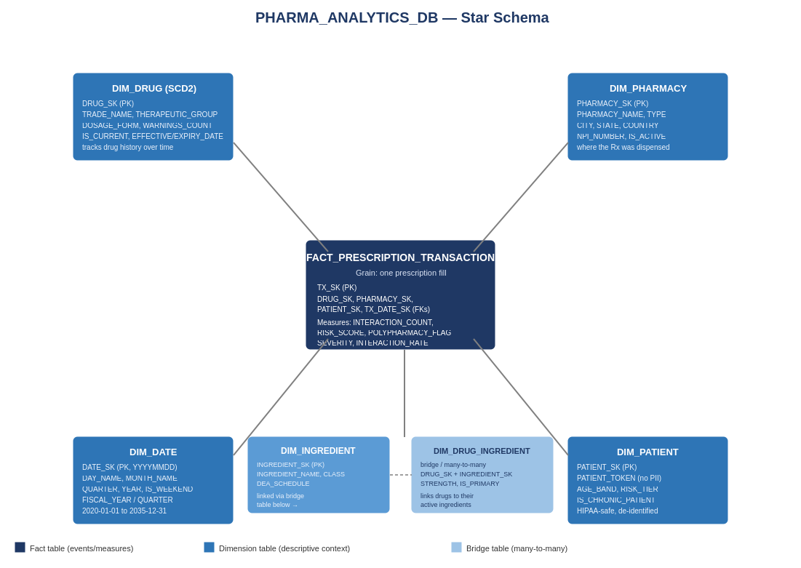

5. What the Code Builds — Block by Block
DataDoseSchema_v3.sql runs in eleven labeled blocks, in dependency order.

5.1 Blocks 0–2 — Warehouse, Database & Schemas, Role & Service User
Creates the X-SMALL auto-suspending PHARMA_WH warehouse, the PHARMA_ANALYTICS_DB database with four schemas (STAGING, DIMENSIONS, FACTS, ANALYTICS), and PYSPARK_ROLE / PYSPARK_SVC for programmatic ETL access — kept separate from your own admin login.

5.2 Block 3 — Staging Tables
STG_DRUG_METADATA and STG_TRANSACTION, VARCHAR-typed landing tables with a RAW_RECORD VARIANT column and an IS_PROCESSED flag that enables incremental loads.

5.3 Block 4 — Dimension Tables
DIM_DATE (pre-populated 2020–2035 via GENERATOR), DIM_DRUG (SCD2), DIM_INGREDIENT, DIM_PHARMACY, DIM_PATIENT, and the DIM_DRUG_INGREDIENT bridge table, built last since it depends on both DIM_DRUG and DIM_INGREDIENT.

5.4 Block 5 — Fact Table
FACT_PRESCRIPTION_TRANSACTION — one row per prescription fill, carrying foreign keys to every dimension plus the interaction/risk measures.

5.5 Block 6 — Analytics Tables
DRUG_INTERACTION_SUMMARY, PHARMACY_RISK_SUMMARY, PATIENT_RISK_PROFILE, and NEO4J_EXPORT_LOG — refreshed periodically rather than computed live. These are the tables Section 6 builds dashboard tiles directly on top of.

5.6 Blocks 7 & 8 — Search Optimization & Row Access Policy (Enterprise only)
Commented out because this account is on Standard edition. Uncomment after upgrading if point-lookup performance or row-level patient access control becomes necessary.

5.7 Block 9 — Views
V_DRUG_INTERACTION_GRAPH (Neo4j export surface), V_HIGH_RISK_PRESCRIPTIONS (real-time clinical alert feed), and V_DRUG_SAFETY_SUMMARY (pre-aggregated per-drug safety KPIs) — all usable on Standard edition and all designed to feed dashboard tiles directly.

5.8 Block 10 — Verification Queries
Row counts, date-range checks, grant checks, and a connectivity smoke test run as PYSPARK_ROLE — confirming the build worked before anything tries to dashboard on top of it.

6. Building the Snowsight Dashboard
Snowsight is Snowflake's built-in dashboarding tool — no separate BI license or export needed. A dashboard is a collection of tiles, and each tile is just a saved SQL query with a chart drawn on top of it. This section shows exactly which table or view to query for each tile, the query itself, and the chart type to pick.
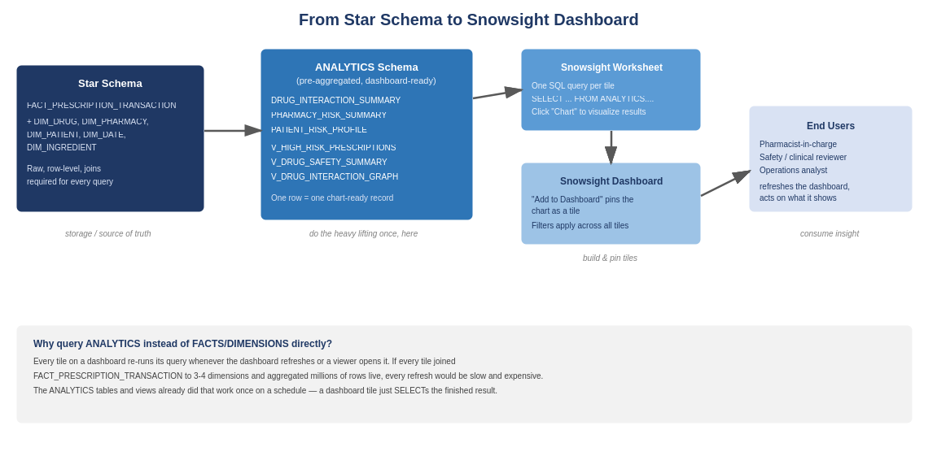

6.1 How a Snowsight Dashboard Is Built, Step by Step
- In Snowsight, go to Projects → Dashboards → + Dashboard, and give it a name (e.g. “DataDose Safety Overview”).
- Inside the dashboard, click + New Tile → From SQL Worksheet, or open a fresh worksheet, write the query, run it, and use “Add to Dashboard” from the worksheet's ... menu.
- After running a query, click the Chart tab next to Results to switch from a results grid to a visual — choose the chart type, then pick which column is the X-axis / category and which is the Y-axis / value.
- Repeat for each tile below, arranging and resizing tiles on the dashboard canvas as needed.
- Add a filter (top-right “Filter” button) bound to a date range or pharmacy name — Snowsight filters can apply across every tile on the dashboard at once if each tile's query references the same filter field.

6.2 Tile 1 — High-Risk Prescriptions Today (KPI number + table)
Source: ANALYTICS.V_HIGH_RISK_PRESCRIPTIONS. This view is already filtered to major-severity, polypharmacy, or high-risk-patient transactions, so no extra filtering logic is needed.
SELECT DRUG_NAME, PHARMACY_NAME, CITY, INTERACTION_SEVERITY,
INTERACTING_DRUGS, PATIENT_RISK_SCORE, TX_DATE
FROM ANALYTICS.V_HIGH_RISK_PRESCRIPTIONS
WHERE TX_DATE = CURRENT_DATE()
ORDER BY PATIENT_RISK_SCORE DESC;
Chart type: leave as a results table (Snowsight tables render directly as dashboard tiles) — this is the one tile meant to be read row by row, not charted. Add a second, tiny tile right above it using COUNT(*) on the same WHERE clause and display it as a single Scorecard number for an at-a-glance count.

6.3 Tile 2 — Top 10 Riskiest Drug Pairs (bar chart)
Source: ANALYTICS.DRUG_INTERACTION_SUMMARY — already pre-aggregated, so this tile is fast even as the fact table grows.
SELECT DRUG_A_NAME || ' + ' || DRUG_B_NAME AS DRUG_PAIR,
OBSERVED_TX_COUNT, INTERACTION_SEVERITY
FROM ANALYTICS.DRUG_INTERACTION_SUMMARY
WHERE INTERACTION_SEVERITY = 'Major'
ORDER BY OBSERVED_TX_COUNT DESC
LIMIT 10;
Chart type: Bar chart. X-axis: DRUG_PAIR. Y-axis: OBSERVED_TX_COUNT. This answers “which dangerous combinations are we actually seeing most often” — the bar length shows real-world frequency, not just theoretical severity.

6.4 Tile 3 — Pharmacy Risk Heatmap (table or bar, sortable)
Source: ANALYTICS.PHARMACY_RISK_SUMMARY joined to DIM_PHARMACY for the readable name, filtered to the latest snapshot date.
SELECT p.PHARMACY_NAME, p.CITY, p.STATE,
prs.AVG_PATIENT_RISK_SCORE,
prs.HIGH_RISK_PATIENT_COUNT, prs.MAJOR_INTERACTION_COUNT
FROM ANALYTICS.PHARMACY_RISK_SUMMARY prs
JOIN DIMENSIONS.DIM_PHARMACY p ON prs.PHARMACY_SK = p.PHARMACY_SK
WHERE prs.SUMMARY_DATE_SK = (SELECT MAX(SUMMARY_DATE_SK)
FROM ANALYTICS.PHARMACY_RISK_SUMMARY)
ORDER BY prs.AVG_PATIENT_RISK_SCORE DESC
LIMIT 15;
Chart type: Bar chart, X-axis PHARMACY_NAME, Y-axis AVG_PATIENT_RISK_SCORE — or leave as a table and use Snowsight's built-in conditional color formatting on the score column for a heatmap feel. This tells a pharmacist-in-charge or ops manager exactly where to focus extra clinical review right now.

6.5 Tile 4 — Interactions Over Time (line chart)
Source: FACT_PRESCRIPTION_TRANSACTION joined to DIM_DATE, aggregated by day — the one tile in this set that goes back to the fact table directly, because PHARMACY_RISK_SUMMARY rolls up by pharmacy, not by therapy-wide totals. Aggregating by day keeps the scan reasonable.
SELECT dd.FULL_DATE,
COUNT(*) AS TOTAL_RX,
SUM(CASE WHEN f.INTERACTION_FOUND = 'TRUE'
THEN 1 ELSE 0 END) AS INTERACTIONS_FOUND
FROM FACTS.FACT_PRESCRIPTION_TRANSACTION f
JOIN DIMENSIONS.DIM_DATE dd ON f.TX_DATE_SK = dd.DATE_SK
WHERE dd.FULL_DATE >= DATEADD('day', -30, CURRENT_DATE())
GROUP BY dd.FULL_DATE
ORDER BY dd.FULL_DATE;
Chart type: Line chart. X-axis: FULL_DATE. Y-axis: plot both TOTAL_RX and INTERACTIONS_FOUND as two series. A rising INTERACTIONS_FOUND line relative to TOTAL_RX volume is the trend a safety officer wants to catch early.

6.6 Tile 5 — Safety Burden by Drug Class (bar or treemap)
Source: ANALYTICS.V_DRUG_SAFETY_SUMMARY — already computes RISK_SCORE and TOTAL_SAFETY_BURDEN per drug, so this tile only needs to roll that up by therapeutic group.
SELECT THERAPEUTIC_GROUP,
COUNT(*) AS DRUG_COUNT,
ROUND(AVG(RISK_SCORE), 2) AS AVG_RISK_SCORE,
SUM(TOTAL_SAFETY_BURDEN) AS TOTAL_BURDEN
FROM ANALYTICS.V_DRUG_SAFETY_SUMMARY
GROUP BY THERAPEUTIC_GROUP
ORDER BY AVG_RISK_SCORE DESC;
Chart type: Bar chart. X-axis: THERAPEUTIC_GROUP. Y-axis: AVG_RISK_SCORE (use TOTAL_BURDEN as a second bar series, or as point size if you switch to a scatter chart). A high average score with a small drug count flags a concentrated risk category worth a closer look, separate from classes that are simply prescribed often.

6.7 Tile 6 — Polypharmacy Patient Trend (line chart)
Source: ANALYTICS.PATIENT_RISK_PROFILE joined to DIM_DATE, aggregated across all patients per day — a population-level view rather than one patient's individual trend.
SELECT dd.FULL_DATE,
COUNT(DISTINCT prp.PATIENT_SK) AS PATIENTS_PROFILED,
SUM(CASE WHEN prp.POLYPHARMACY_FLAG
THEN 1 ELSE 0 END) AS POLYPHARMACY_COUNT,
ROUND(AVG(prp.PATIENT_RISK_SCORE), 2) AS AVG_RISK_SCORE
FROM ANALYTICS.PATIENT_RISK_PROFILE prp
JOIN DIMENSIONS.DIM_DATE dd ON prp.PROFILE_DATE_SK = dd.DATE_SK
WHERE dd.FULL_DATE >= DATEADD('day', -90, CURRENT_DATE())
GROUP BY dd.FULL_DATE
ORDER BY dd.FULL_DATE;
Chart type: Line chart, X-axis FULL_DATE, two series: POLYPHARMACY_COUNT and AVG_RISK_SCORE. This is the tile that shows whether the patient population is trending safer or riskier over the last quarter.

6.8 Putting it together: a suggested dashboard layout
- Top row: Tile 1's scorecard (today's high-risk count) next to Tile 4 (30-day interaction trend line) — the “is today normal” view.
- Middle row: Tile 2 (riskiest drug pairs) and Tile 3 (pharmacy risk ranking) side by side — the “where is risk concentrated” view.
- Bottom row: Tile 5 (safety burden by drug class) and Tile 6 (polypharmacy trend) — the “big picture over time” view.
- Full-width at the very bottom: Tile 1's detailed table, for drilling into specific cases after spotting a pattern above.

6.9 Keeping the dashboard fast
- Every query above reads from ANALYTICS tables/views or aggregates the fact table by day — never an unaggregated row-by-row scan of the full fact table on a dashboard tile.
- Filter DIM_DRUG (directly or through a view) on IS_CURRENT = TRUE unless a tile specifically wants historical drug versions, or SCD2 history can silently duplicate rows in a chart.
- If ANALYTICS.PHARMACY_RISK_SUMMARY or PATIENT_RISK_PROFILE isn't refreshing on the schedule you expect, check the ETL job that populates them — a dashboard tile is only ever as current as its underlying ANALYTICS table.
- Snowsight dashboards can be set to auto-refresh on an interval (dashboard settings, top right) — match that interval to how often the ANALYTICS layer actually updates, so the dashboard isn't re-running expensive queries against unchanged data.

7. Quick-Reference Glossary
Term | Meaning
Fact table | Stores measurable events with numeric measures. Here: FACT_PRESCRIPTION_TRANSACTION.
Dimension table | Stores descriptive context (who/what/where/when) that a fact links to.
Grain | What one row of a fact table represents. Here, one row = one prescription fill.
SCD Type 2 | Tracks history by inserting a new row (and closing the old one) instead of overwriting. Used on DIM_DRUG.
ANALYTICS schema | Pre-aggregated tables/views refreshed on a schedule, built specifically so dashboard tiles don't need to scan raw fact data live.
Snowsight | Snowflake's built-in web UI for worksheets and dashboards — no separate BI tool required.
Tile | One chart or table on a Snowsight dashboard, backed by one saved SQL query.
Scorecard | A Snowsight chart type that shows a single number prominently — good for KPIs like “today's high-risk count.”
Dashboard filter | A control bound to a column (e.g. date range) that can apply across every tile on the dashboard simultaneously.

RELATED DOCUMENTS | Pair this guide with the New Account Setup Guide for the schema/account details, and the PySpark Pipeline Guide for how ANALYTICS tables stay populated by the live ingestion pipeline.

